Stage 2, Bay 1: Cobra Standards
RULES: USPSA Competition Rules COURSE DESIGNER: Jodi Humann, L3876
START POSITION: Handgun: Standing inside the appropriate shooting area with wrists above respective shoulders. Handgun is loaded and holstered. PCC: Standing inside the appropriate shooting area, facing down range with PCC held in both hands with stock on belt and muzzle pointed downrange. PCC is loaded with safety on.
STAGE PROCEDURE  All strings are 4 seconds.  String 1: On signal from box A engage T1-T3 with only 2 rounds each, freestyle.  String 2: On signal from box B engage T1-T3 with only 2 rounds each, strong hand only (PCC: Strong side only).  String 3: On signal from box C engage T1-T3 with only 2 rounds each, weak hand only (PCC: Weak side only). | SCORING  SCORING: Fixed Time, 18 rounds, 90 points  TARGETS: 3 IPSC  SCORED HITS: Best 6 per paper  START-STOP: Audible - Audible  PENALTIES: Per current edition of USPSA Competition Rules

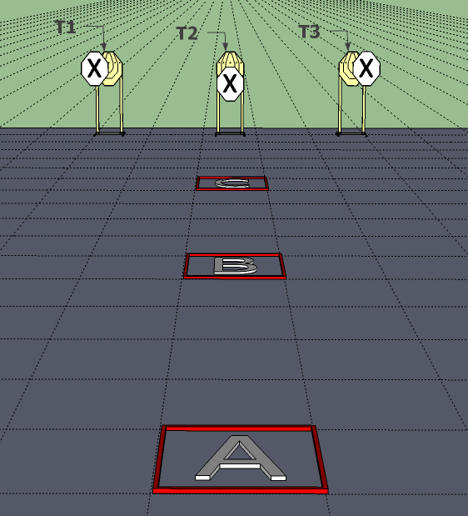

SETUP NOTES: |  | RO NOTES: Rule 9.4.6.2, all shots over 4.30 sec are overtime. No FTSA penalties, and misses are NPM (9.2.4.4)

Overhead view, Stage 2, Bay 1: Cobra Standards, 3 ft x 3 ft grid

Back of Bay (Down Range)
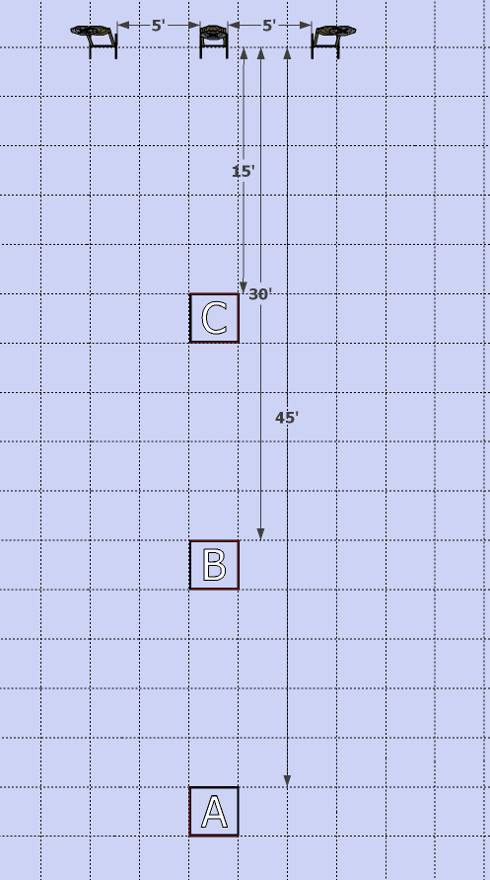
Front of Bay (Up Range)

Target Detail, Stage 2, Bay 1: Cobra Standards
T1 | T2 | T3
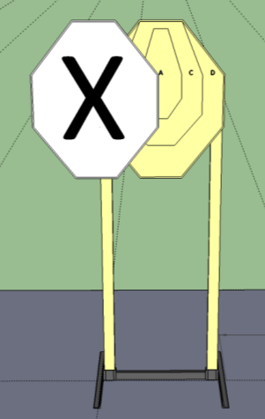 | 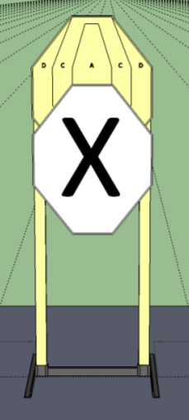 | 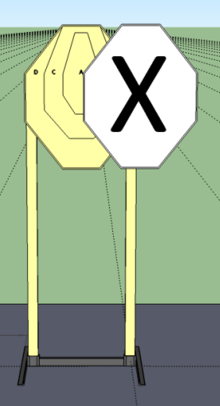
Right corner of NS on letter “A” | Top edge of NS lines up with corners of A-zone | Left corner of NS on letter “A”

Stage 3, Bay 2: Triple Tap Taipan
RULES: USPSA Competition Rules COURSE DESIGNER: Jodi Humann, L3876
START POSITION: Handgun: Standing anywhere inside the shooting area, with hands relaxed at sides. Handgun is loaded and holstered. PCC: Standing anywhere inside the shooting area, with PCC held in both hands with stock on belt and muzzle pointed downrange. PCC is loaded with safety on.
STAGE PROCEDURE  Upon start signal engage targets as they become visible from within the fault lines. | SCORING  SCORING: Comstock, 20 rounds, 100 points  TARGETS: 6 USPSA, 2 USPSA Poppers  SCORED HITS: Best 3 per paper, steel down = 1A  START-STOP: Audible - Last shot  PENALTIES: Per current edition of USPSA Competition Rules

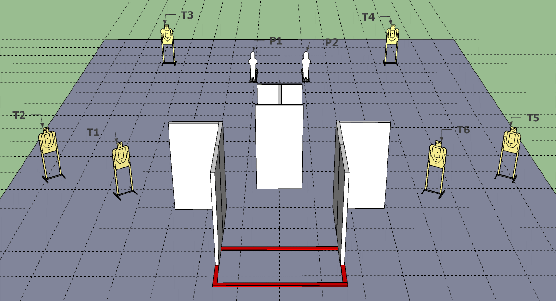

SETUP NOTES: Poppers are 6 ft apart, shooting area is 9 ft wide and 4 ft deep, side fault lines are 2 ft. |  | RO NOTES:

Overhead view, Stage 3, Bay 2: Triple Tap Taipan

Back of Bay (Down Range)
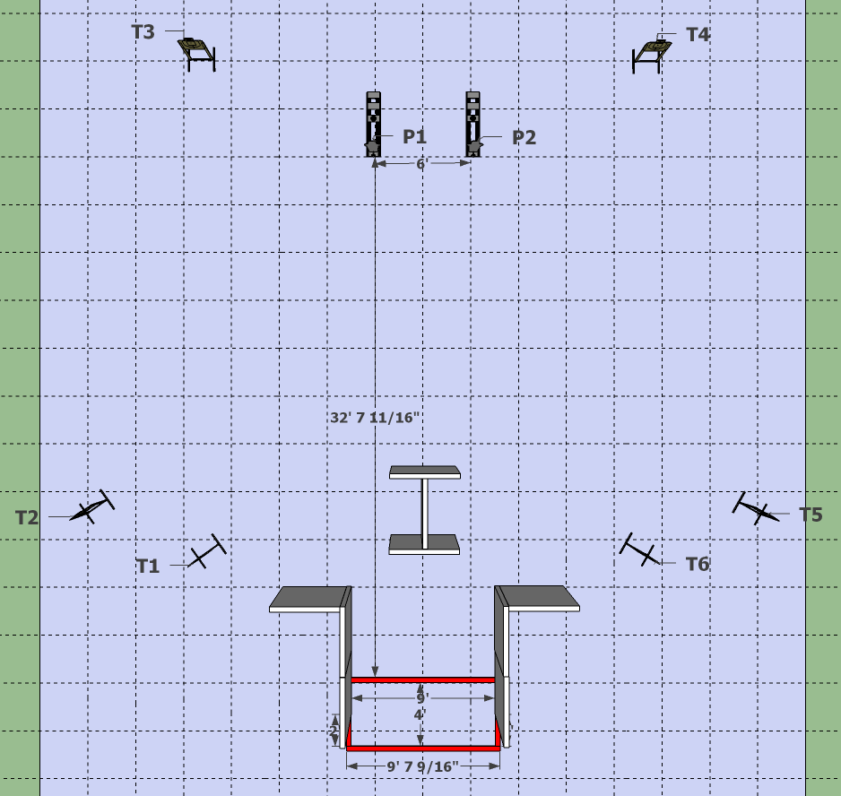
Front of Bay (Up Range)

Target Detail, Stage 3, Bay 2: Triple Tap Taipan

T1-T6
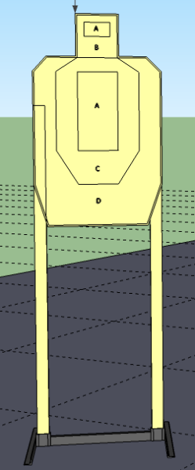

Stage 10, Bay 8: Sidewinder
RULES: USPSA Competition Rules COURSE DESIGNER: Jodi Humann, L3876
START POSITION: Handgun: Standing outside the shooting area with toes on X marks. Hands relaxed at sides. Handgun is loaded and holstered. PCC: Standing outside the shooting area with toes on X marks, with PCC held in both hands with stock on belt and muzzle pointed downrange. PCC is loaded with safety on.
STAGE PROCEDURE  Upon start signal engage targets as they become visible from within the fault lines. | SCORING  SCORING: Comstock, 24 rounds, 120 points  TARGETS: 11 USPSA, 2 Poppers  SCORED HITS: Best 2 per paper, steel down = 1A  START-STOP: Audible - Last shot  PENALTIES: Per current edition of USPSA Competition Rules

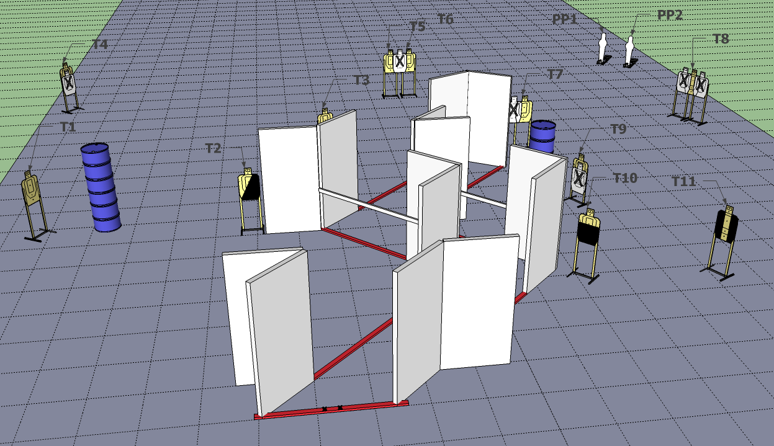

SETUP NOTES: T3 and T9 are short targets. Barrels are hard cover. Put rails across openings as shown. |  | RO NOTES:

Overhead view, Bay 8, Stage 10: Sidewinder, 3 ft x 3 ft grid

Back of Bay (Down Range)
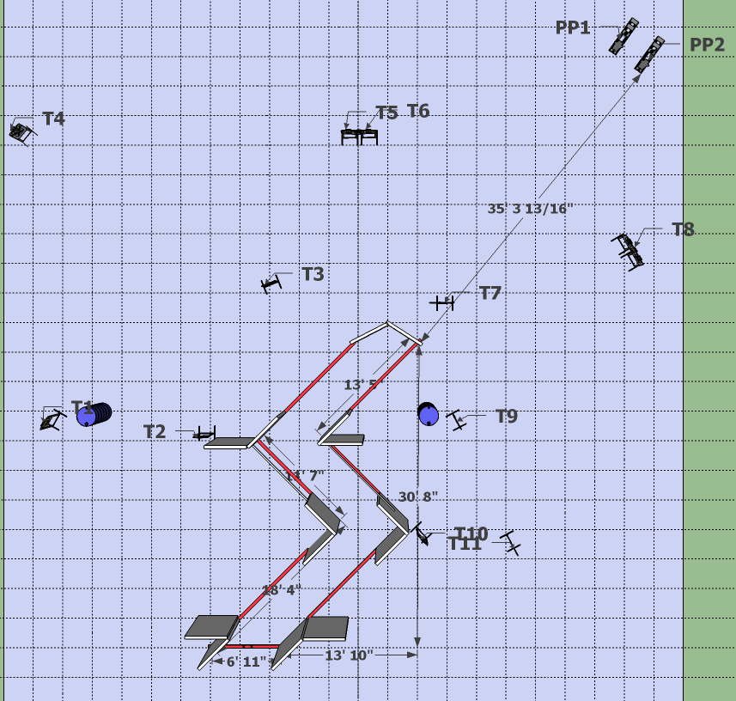
Front of Bay (Up Range)

Target Detail, Bay 8, Stage 10: Sidewinder

T1 is a USPSA target at standard height. T3 is a short USPSA target.

T2 | T4 | T5 and T6
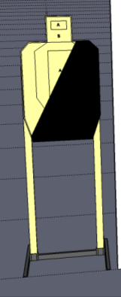 | 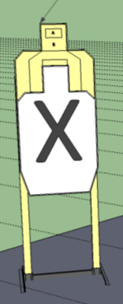
T7 | T8 | T9
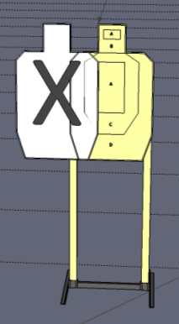 | 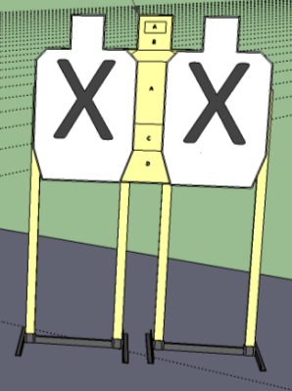 | 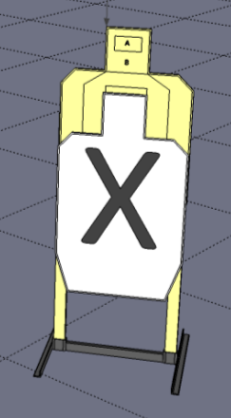
T10 | T11

